Machine Language

📌 Definition:
# Source: AI Source: Provided by: [Data Path: Persons Table -> ID Column: 1, Name_En Column: Motasem Essam] -> From: [Chatgpt (GPT‑5 Mini)] on [12/9/2025]
Machine language is the lowest-level programming language, written in binary (0s and 1s), and it is directly understood by the computer’s CPU.

🧠 Simple idea:
# Source: AI Source: Provided by: [Data Path: Persons Table -> ID Column: 1, Name_En Column: Motasem Essam] -> From: [Chatgpt (GPT‑5 Mini)] on [12/9/2025]
Machine Language = The only language the computer truly understands

🔍 Characteristics:
# Source: AI Source: Provided by: [Data Path: Persons Table -> ID Column: 1, Name_En Column: Motasem Essam] -> From: [Chatgpt (GPT‑5 Mini)] on [12/9/2025]
- ✅ Written in binary digits (0, 1)
- ✅ No translation needed (no compiler/interpreter)
- ✅ Executes very fast
- ❌ Extremely hard for humans to read and write
- ❌ Error-prone

🧩 Example:
# Source: AI Source: Provided by: [Data Path: Persons Table -> ID Column: 1, Name_En Column: Motasem Essam] -> From: [Chatgpt (GPT‑5 Mini)] on [12/9/2025]
10110000 01100001
👉 Each binary instruction tells the CPU exactly what to do (like move data, add numbers, etc.)

⚙️ How it works:
# Source: AI Source: Provided by: [Data Path: Persons Table -> ID Column: 1, Name_En Column: Motasem Essam] -> From: [Chatgpt (GPT‑5 Mini)] on [12/9/2025]
- Instructions are written in binary
- CPU reads them directly
- Executes operations (add, move, compare, etc.)

🆚 Machine Language vs Others
# Source: AI Source: Provided by: [Data Path: Persons Table -> ID Column: 1, Name_En Column: Motasem Essam] -> From: [Chatgpt (GPT‑5 Mini)] on [12/9/2025]
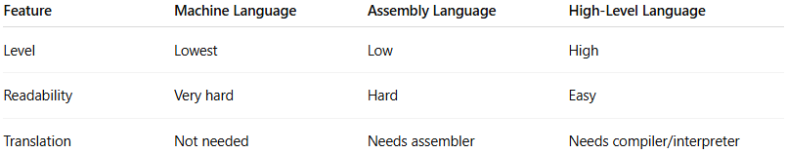
Feature | Machine Language | Assembly Language | High-Level Language
Level | Lowest | Low | High
Readability | Very hard | Hard | Easy
Translation | Not needed | Needs assembler | Needs compiler/interpreter

⚠️ Important:
# Source: AI Source: Provided by: [Data Path: Persons Table -> ID Column: 1, Name_En Column: Motasem Essam] -> From: [Chatgpt (GPT‑5 Mini)] on [12/9/2025]
- Each computer architecture (CPU type) has its own machine language
- Not portable between different systems

✅ Summary:
# Source: AI Source: Provided by: [Data Path: Persons Table -> ID Column: 1, Name_En Column: Motasem Essam] -> From: [Chatgpt (GPT‑5 Mini)] on [12/9/2025]
Machine language is the raw, binary instructions executed directly by hardware—fast but not human-friendly at all.

